From: http://nymag.com/daily/intelligencer/2015/04/61-times-kristol-reminded-of-hitler-churchill.html

THE NATIONAL INTERESTApril 29, 2015 8:00 a.m.

61 Times Bill Kristol Was Reminded of Hitler and Churchill
By Jonathan Chait Follow @jonathanchait
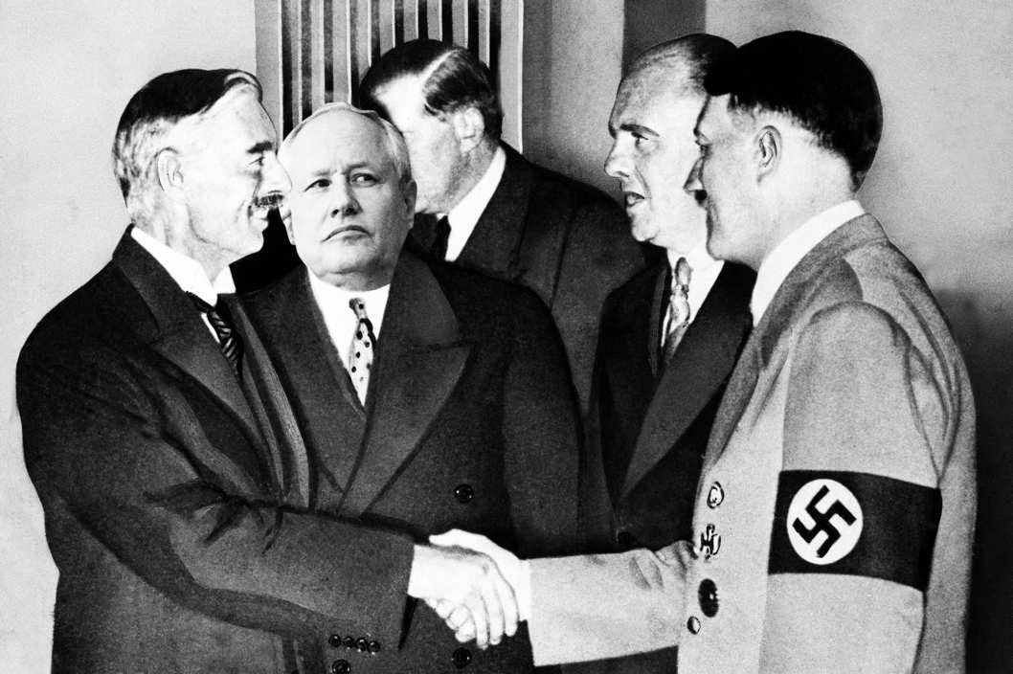
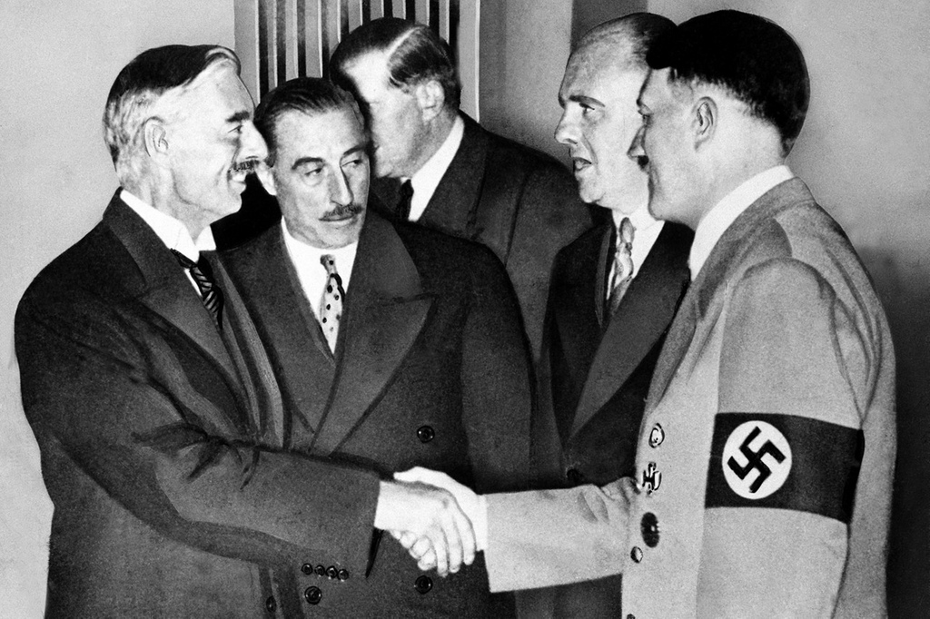Photo: AP Images, Getty Images
Weekly Standard editor William Kristol, writing in opposition to the Iran deal recently, observed, “One is reminded — as one so often is these days — of Churchill’s great speech in Commons after Munich ... ” It is true that Kristol is often reminded of Churchill and Munich these days. This may not tell us anything about the current situation with Iran, however, since Kristol is reminded of Churchill and Munich on a great many days. It is a historic reference he has used to explain a great many episodes.
I recently asked New York interns Claire Landsbaum and Claire Voon to compile a list of Kristol’s public references to the Munich agreement and its main players. This research ordeal, presented in reverse chronological order, represents the sort of character-building exercise, I am sure Kristol would agree, that today’s youth badly need.
1. Benjamin Netanyahu condemns the Iran deal.
"And in pondering the path of the Obama administration, I couldn’t get out of my mind Winston Churchill’s admonition to Neville Chamberlain after Munich: 'You were given the choice between war and dishonor. You chose dishonor and you will have war.'" (4/6/2015)
2. Obama’s appeasement-y deal with Iran.
"Britain has a parliamentary system of government, and so Neville Chamberlain's parliamentary majority ensured the Munich agreement would go forward. The U.S. Constitution, on the other hand, provides for a separation of powers." (4/4/2015)
3. Obama’s appeasement-y deal with Iran.
"Seth Lipsky of the New York Sun grasps the significance of the moment in his editorial today … 'Let Congress return the burden to the President. Let it challenge the president’s claim that a negotiated agreement 'is our best option by far,' or what the New York Times calls 'unquestionably the best approach.' Such talk reminds us of Geoffrey Dawson, who was editor of the London Times in the 1930s and the journalistic apostle of Britain’s appeasement of Hitler; Dawson called the Nazi peace offer 'the best immediate hope.'" (4/3/2015)

Related Stories
If This Is the Best Defense of the Clinton Foundation, She’s in TroubleRepublicans Are Trying Very Hard, But They Won’t Pull Off PopulismThe Inevitable Salon Defense of Kazakhstan’s Election System Is Finally Here and It’s More Amazing Than You Could Have Imagined
4. Benjamin Netanyahu’s bold speech to Congress.
"He is inspired by the example of Ze’ev Jabotinsky — and also of Winston Churchill ... When Netanyahu walks to the podium of the House of Representatives on March 3, he’ll undoubtedly have in mind an earlier speech given by a foreign leader to a joint meeting of Congress. On December 26, 1941, Winston Churchill addressed Congress, though in the smaller Senate Chamber rather than in the House, as so many members were out of town for Christmas break.
Churchill enjoyed the great advantage in December 1941 of having an American president who, after Pearl Harbor, was a clear and unambiguous ally in the war for the West. Netanyahu has no such advantage. So it might be hard for him to say, as Churchill did, that here in Washington he had 'found an Olympian fortitude which, far from being based upon complacency, is only the mask of an inflexible purpose and the proof of a sure, well-grounded confidence in the final outcome.'" (3/9/2015)
5. President Obama’s “assault” on Netanyahu.
"While he may be less familiar than Obama with fictional movies like Bulworth, Netanyahu is undoubtedly familiar with the following historical moment: Just over 75 years ago, on September 2, 1939, Arthur Greenwood, deputy leader of the Labour party, rose in the House of Commons in response to remarks by Prime Minister Neville Chamberlain to speak for Labour. Greenwood was famously interrupted by the Conservative backbencher and fierce critic of appeasement Leo Amery, who startled the House by shouting across the aisle, "Speak for England!'" (3/23/2015)
6. The imminent collapse of western civilization, just in general.
"The civilizational collapse of the 1930s, in reaction to the Great War and then the Great Depression, could well have led to an unbelievably brutal world dominated for decades by tyrannical communism, barbaric National Socialism, and fanatical Japanese militarism. Winston Churchill wasn’t exaggerating in June 1940 when he said that if Britain, which then stood virtually alone, failed, 'The whole world, including the United States, including all that we have known and cared for, will sink into the abyss of a new Dark Age made more sinister, and perhaps more protracted, by the lights of perverted science.' …
It was bad in 1935. It was bad, in 1975. It is bad in 2015. More perhaps than in the earlier years, there are impressive leaders elsewhere — from Stephen Harper in Canada to Narendra Modi in India, from Benjamin Netanyahu in Israel to Tony Abbott in Australia. But we have Barack Obama. He has chosen, quite purposefully, to play the role of Neville Chamberlain or at least Jimmy Carter." (2/16/2015)
7. President Obama’s cowardly Israel policy.
"And so Obama lashes out.
It's of course unseemly. But it's also dangerous. Neville Chamberlain and the British establishment were far angrier with Winston Churchill, and much harsher in their attempts to discredit him, in the late 1930s when the dreams of appeasement were failing, than earlier, when hope for the success of appeasement was alive." (1/29/2015 )
8. The Nazi-like Charlie Hebdo attacks.
"In late 1936, Winston Churchill warned the House of Commons, 'The era of procrastination, of half-measures, of soothing and baffling expedients, of delays is coming to its close. In its place we are entering a period of consequences.'
We face a crisis of Islam." (1/19/2015)
9. Obama’s appeasement-y foreign policy in general.
"Are they horrified by the results of Obama’s foreign policy? Let them study Churchill: 'For five years I have talked to the House on these matters—not with very great success. I have watched this famous island descending incontinently, fecklessly, the stairway which leads to a dark gulf. It is a fine broad stairway at the beginning, but after a bit the carpet ends. A little farther on there are only flagstones, and a little farther on still these break beneath your feet.'" (10/13/2014 )
10. Eric Cantor’s defeat.
"This November, voters across America will render, we’re increasingly confident, a verdict of no confidence in the Democratic establishment. One could say that the establishments of both parties are 'dead broke.'
When Arthur Greenwood rose to speak in the House of Commons on September 2, 1939, responding to Prime Minister Neville Chamberlain on behalf of the opposition Labour party, the redoubtable Leo Amery called out from the Conservative back benches: 'Speak for England!' Will a Republican presidential candidate, in this moment of confusion and crisis, rise to speak for America?" (7/23/2014)
11. Obama’s appeasement in Afghanistan.
"But the consequences of continued American weakness and retreat are awful to contemplate. For what we see around the world today is, as Winston Churchill said in October 1938, 'only the beginning of the reckoning. This is only the first sip, the first foretaste of a bitter cup which will be proffered to us year by year unless by a supreme recovery of moral health and martial vigour, we arise again and take our stand for freedom as in the olden time.'" (6/9/2014 )
12. Some Weekly Standard readers may have missed the previous week’s edition.
"Last week, reacting to the president’s decision to remove troops from Afghanistan by the end of 2016 and, more broadly, to President Obama’s policy of American weakness and retreat, we quoted in this space Winston Churchill: 'This is only the first sip, the first foretaste of a bitter cup which will be proffered to us year by year unless by a supreme recovery of moral health and martial vigour, we arise again and take our stand for freedom as in the olden time.'" (6/16/2014)
13. Obama’s appeasement of Russia, Iran, and Syria.
"We’re tempted to produce at this point appropriate Winston Churchill warnings and statements from the 1930s. But the current situation is almost too pathetic to be worthy of Churchillian exhortation. … All of which leads us — in this instance at least — to cite the Lincoln of 1838 rather than the Churchill of 1938." (3/3/2014 )
Note: This is arguably not quite a reference to Churchill/Hitler, but it seems to fall just over the line.
14. Obama’s appeasement of Iran.
"We’re also obliged to ask what the deal tells us about our president and his view of the world.
There’s an obvious comparison of Barack Obama to Neville Chamberlain, the British prime minister who pursued a policy of appeasing Adolf Hitler, culminating in the Munich conference of 1938. There, Chamberlain and the French premier agreed to Hitler’s demand that Czechoslovakia should cede the Sudetenland to Nazi Germany to stave off a threatened German invasion, without the Czechs even being a party to the talks.
Obama does manifest some of Chamberlain’s trusting naïveté and insular self-righteousness. More important perhaps, like Chamberlain, Obama thinks his job is to accommodate domestic war-weariness and to keep us out of foreign conflicts. Also like Chamberlain, Obama in the Middle East has inclined toward appeasing Muslims at the expense of Jews in the Holy Land. And like Chamberlain, Obama will go down in history as a failed leader of the leading Western democracy, one whose policies will have to be reversed — one hopes this time at less cost — by his successor.
Churchill succeeded Chamberlain in May 1940, and saved the West…" (12/9/2013)
15. The 75-year anniversary of the Geneva Agreement.
"In light of the Geneva Agreement, I went back to read Winston Churchill's October 5, 1938, speech in the House of Commons on the Munich Agreement. Here are a few highlights … (11/24/2013)
16. Netanyahu’s bold United Nations speech.
"The most dramatic part of his speech was Netanyahu’s declaration: 'I want there to be no confusion on this point. Israel will not allow Iran to get nuclear weapons. If Israel is forced to stand alone, Israel will stand alone.'Netanyahu, who has a photo of Winston Churchill on his office wall behind his desk, was echoing Churchill’s remark on July 14, 1940, during the Battle of Britain: 'And now it has come to us to stand alone in the breach.'
He sees that behind the Obama administration’s façade of hard-headed diplomacy is a soft-headed, even desperate, desire for some sort of deal, any deal, and that such a deal will be rationalized by foreign policy elites who know it’s a bad deal but who have talked themselves into accepting the case for containment rather than prevention of a nuclear Iran. And Netanyahu understands that behind all of this lies a failure of nerve and a collapse of will in much of the West that deserves to be compared to what Churchill faced in the 1930s.
Netanyahu said at the U.N. that 'in standing alone, Israel will know that we will be defending many, many others.' This too echoes Churchill in his July 1940 speech: 'We are fighting by ourselves alone; but we are not fighting for ourselves alone.' Churchill asserted that London, “which enshrines the title deeds of human progress,” was defending civilization itself. So today, if Israel​ — ​an outpost of human progress in the Middle East ​— ​decides that she has no choice but to attack Iran’s nuclear facilities, Israel will not be fighting for herself alone." (10/14/2014 )
17. Obama’s appeasement of Iran.
"The West’s failure to resist Mussolini’s invasion of Ethiopia in 1935 — and his troops’ use of poison gas — was merely a foretaste of the failure to resist Hitler when he took the Rhineland in March 1936. … the accommodation of the Islamic Republic of Iran’s quest for nuclear weapons lies ahead as surely as the accommodation of Nazi Germany’s expansionist dreams. … And the Obama administration, too, will play its role, echoing the Baldwin government, which Winston Churchill in 1936 characterized as 'decided only to be undecided, resolved to be irresolute, adamant for drift, solid for fluidity, all-powerful to be impotent.' Churchill continued, 'So we go on preparing more months and years — precious, perhaps vital to the greatness of Britain — for the locusts to eat.'
As Iran moves closer to nuclear weapons, undeterred by the West’s leading power, a 21st-century tragedy threatens to unfold. Unless. Unless adramatis persona who didn’t exist in 1936 intervenes: Israel. Ariel Sharon once famously said that Israel would not play the role of Czechoslovakia in the 1930s." (9/30/2013)
18. President Obama’s appeasement of Syria.
"As he played his part in making the case for military action, John Kerry referred to this as our century’s Munich moment. He spoke more truly than he meant, for his boss followed the precedent of Munich rather than learning his lesson. But Obama’s Munich moment turned out to be a Marxian version, with Obama doing farcical pratfalls as he followed down Neville Chamberlain’s tragic path. …
In the spirit of Churchill’s great October 5, 1938, speech in response to the Munich agreement, those here at home who are unwilling to consign Americans to either tragedy or farce could insist that people 'should know the truth. They should know that there has been gross neglect and deficiency in our defences; they should know that we have sustained a defeat without a war, the consequences of which will travel far with us along our road.'
And they could explain, soberly and honestly, what Churchill said in concluding his remarks on the floor of the House of Commons … " (9/23/2013)
19. President Obama’s potential non-appeasement of Syria.
"They’re wrong. Winston Churchill noted that 'the Muse of History must not be fastidious.' Likewise the Muse of editorialists. So we’ll be forgiven, we trust, for briefly laying out the crass political reasons why Republicans should vote Yes." (9/16/2013)
20. President Obama’s appeasement of Syria.
"Presumably Obama didn't know the context of his quotation from FDR. But it seems inadvertently fitting that Obama quoted not the FDR who fought Hitler but the FDR of the 1930s. As it happens, the day after the San Diego speech, Mussolini invaded Ethiopia. Italian troops repeatedly and brazenly used poison gas in that conflict. The world, including of course the U.S., expressed 'deep concern' — but did nothing.
As Obama now seems to be finding excuses to do nothing." (9/10/2013 )
21. The use of force in Syria.
"We need to persuade the Congress and the country to pass a resolution authorizing the use of force; and we need to persuade the administration (against its predilections) to take strong and decisive action. Both may be difficult. But, as Churchill once remarked, 'difficulties mastered are opportunities won.'" (8/31/2013)
22. Budget cuts to the Defense Department.
"Larkin wrote 'Homage' almost a quarter-century after the end of World War II. In the darkest moments of that war, on June 18, 1940, when Britain stood alone, Churchill famously proclaimed: 'Let us therefore brace ourselves to our duties and so bear ourselves that, if the British Empire and its Commonwealth last for a thousand years, men will still say, 'This was their finest hour.' So it was, and so men say it still — but in a mood of nostalgia for past glory." (8/12/2013 )
23. Old people are bad, except when they’re conservative, in which case, they’re good.
"This includes the young in spirit, of course. Chronology is not destiny. In 1980 the 69-year-old Ronald Reagan was more youthful in attitude than all the earnest 30-year-old establishment wannabes. In 1940 the 65-year-old Winston Churchill was more youthful in spirit than all the world-weary appeasers born decades after him. (7/8/2013 )
24. President Obama’s cowardly speech in Berlin.
"It wouldn’t be too harsh to say of Obama’s foreign policy what Winston Churchill said in 1936 about the Stanley Baldwin government: He is 'decided only to be undecided, resolved to be irresolute, adamant for drift, solid for fluidity, all-powerful to be impotent.'" (7/1/2013 )
25. Obama’s appeasement of Syria.
"Western leaders once understood this game too. Here’s Winston Churchill, over a half century ago … " (5/13/2013 )
26. Obama’s appeasement of Syria.
"If the government of the United States is unwilling to do anything but present to the world the sorry spectacle of justice without a sword or justice unwilling to use the sword, surely it would be better to say nothing. If the Obama administration is, as Churchill put it in November 1936, 'decided only to be undecided, resolved to be irresolute, adamant for drift, solid for fluidity, all-powerful to be impotent,' then it should have the decency to keep silent rather than engage in such pitiable and contemptible posturing." (5/4/2013)
27. The Boston bombings.
"The 20th century didn’t lack for barbarians. Indeed, modern barbarism proved more dangerous than the old-fashioned kind. As Churchill put it in his great House of Commons speech on June 18, 1940, after the fall of France, rallying Britain against the National Socialist tyranny in Germany: 'But if we fail, then the whole world, including the United States, including all that we have known and cared for, will sink into the abyss of a new dark age made more sinister, and perhaps more protracted, by the lights of perverted science.'" (4/29/2013 )
28. Budget cuts to the Defense Department.
"'The gratitude of every home in our island, in our Empire, and indeed throughout the world, except in the abodes of the guilty, goes out to the British airmen who, undaunted by odds, unwearied in their constant challenge and mortal danger, are turning the tide of the world war by their prowess and by their devotion. Never in the field of human conflict was so much owed by so many to so few.'
—Winston Churchill, tribute to the Royal Air Force, House of Commons, August 20, 1940
The Royal Air Force turned the tide of war in 1940. American soldiers and Marines turned the tide of war in Iraq in 2007-08, and in Afghanistan in 2010-11. They deserve tributes similar in spirit, if not quite in grandeur, to that paid by Churchill to the British airmen of 1940. ... " (11/26/2012)
29. Western civilization is under attack, just in general.
"From the Great Terrors of Stalin and Hitler to the attacks on New York and Tel Aviv, and on Madrid, Bali, and Mumbai, terrorists of all stripes know who their enemies are. They attack across the world and kill Jews, Christians, and Muslims alike — but they grasp that the centers of resistance, the nations that stand most squarely in their path, are the United States and Israel." (11/22/2012)
30. Mitt Romney’s second bold presidential debate.
"On September 2, 1939, the day after Hitler invaded Poland, Prime Minister Neville Chamberlain made clear in the House of Commons that he still entertained hopes for negotiations with Hitler: 'If the German Government should agree to withdraw their forces then His Majesty’s Government would be willing to regard the position as being the same as it was before the German forces crossed the Polish frontier. That is to say, the way would be open to discussion between the German and Polish Governments on the matters at issue.'
The acting leader of the opposition, Arthur Greenwood, rose to reply to the prime minister. He began by saying he would be speaking on behalf of the Labour party. The prominent Conservative and opponent of appeasement Leo Amery, appalled by what Chamberlain had said, dramatically interrupted Greenwood from the Tory backbenches, shouting across the hall: 'Speak for England, Arthur!'" (10/19/2012)
31. Mitt Romney’s bold first presidential debate.
"Perhaps because Mitt Romney is a Winston Churchill fan and Barack Obama is not, I thought this morning of Churchill's 'end of the beginning' remarks, delivered almost 70 years ago, at Mansion House in London, on November 10, 1942. Here are a few relevant lines … " (10/4/2012)
32. The Obama administration’s appeasement of Muslims protesting The Innocence of Muslims.
"Perhaps the Obama administration should buy airtime in Pakistan to condemn everyone who's ever said anything problematic about Islam.
For example, Winston Churchill." ... (9/20/2012)
33. Obama’s appeasement of Iran.
"Two years ago, we wrote in these pages that we were entering with respect to Iran what Winston Churchill called in 1936 a 'period of consequences,' in which 'the era of procrastination, of half-measures, of soothing and baffling expedients, of delays is coming to its close.'
At the end of his 'period of consequences' remarks in the House of Commons in November 1936, Churchill said ... " (6/25/2012)
34. Marines urinating on Taliban corpses in Afghanistan.
"It wasn’t just American generals who seemed preoccupied with pissing back in 1945. Three weeks earlier, Winston Churchill had visited the front lines near Jülich. Churchill had long dreamed of urinating on Hitler’s much-vaunted Siegfried Line to show his contempt for Hitler and Nazism." ... (1/23/2012)
35. A poll says the U.S. and the U.K. agree that war is sometimes necessary.
"It’s also interesting that the only EU country polled that has a majority willing to say war is sometimes necessary is Great Britain, whose numbers — 64-32 — put its people much closer to Americans in world view than to Europeans. The spirit of Thatcher (and Churchill?) may live. But what remains of the rest of the West?" (9/6/2011)
36. Leon Panetta’s appeasement of Obama.
"Obama still appears unwilling to protect defense, even as he continues to protect the programs that are the true source of our fiscal woes​ — ​entitlements and runaway domestic spending. As we have pointed out before on this page, America now faces a 'period of consequences,' like the one Churchill predicted in the 1930s as he warned that Britain was increasingly unprepared for the challenges that lay ahead.
Speaking to the House of Commons in 1935, Churchill said ... " (6/20/2011)
37. President Obama’s actually okay-ish speech.
"The close, was, I thought, well done. The president located those who fought in Iraq in the unbroken line of those who, from Lexington to Kandahar, 'gave their lives for the values that have lived in the hearts of our people for over two centuries' and who 'have fought to see that the lives of our children are better than our own.' There was a welcome implicit repudiation of Neville Chamberlain and appeasement, as President Obama praised our troops for having 'fought in a faraway place for people they never knew.'" (8/31/2010)
38. Kristol repeating Churchill quote from last month’s issue.
"Last month, we published an editorial under the title 'A Period of Consequences.' The phrase was taken from a speech in the House of Commons in late 1936 in which Winston Churchill warned: 'The era of procrastination, of half-measures, of soothing and baffling expedients, of delays is coming to its close. In its place we are entering a period of consequences.'
But looking at the world in the summer of 2010, we’re struck that we have entered a period of consequences on many more fronts than just the Iranian nuclear program. Churchill’s words seem to capture all too many aspects of the present moment." (7/26/2010 )
Note: Kristol’s policy of alerting readers to his reuse of a Churchill quote seems to be applied inconsistently.
39. Obama’s appeasement of Iran.
"In a speech to the House of Commons in late 1936, Winston Churchill warned, 'The era of procrastination, of half-measures, of soothing and baffling expedients, of delays is coming to its close. In its place we are entering a period of consequences.'" (6/21/2010)
40. Obama’s appeasement of Iran.
"In March 1936, Hitler occupied the Rhineland. The French prime minister, Leon Blum, denounced the act as 'unacceptable.' But France, Britain and the rest of the world accepted it. Years later, the French political thinker Raymond Aron commented, 'To say that something is unacceptable was to say that one accepted it.'
In March 2010, as Iran moved ahead with its nuclear weapons program, the American secretary of state, Hillary Clinton, speaking at the policy conference of the American Israel Public Affairs Committee last week, said no fewer than four times in one paragraph that a nuclear-armed Iran would be 'unacceptable.'" (3/28/2010 )
41. The injustice of McCain’s loss.
"John McCain said repeatedly that he'd rather lose an election than lose a war. We ended up winning a war, and he ended up losing the election. It's not quite the cosmic injustice of the British electorate rejecting Churchill in 1945 — but it's no small injustice either." (11/17/2008 )
42. Obama has fine temperament and intellect, like Neville Chamberlain.
"If he'd had his way, Obama would have lost the war in Iraq — with equanimity. He would have been calm, cool, and collected as U.S. interests were sacrificed and U.S. honor besmirched. Neville Chamberlain also had a fine temperament and a good intellect." (11/3/2008 )
43. Russian troops in Georgia.
"When the 'civilized world' expostulated with Russia about Georgia in 1924, the Soviet regime was still weak. In Germany, Hitler was in jail. Only 16 years later, Britain stood virtually alone against a Nazi-Soviet axis. Is it not true today, as it was in the 1920s and ’30s, that delay and irresolution on the part of the democracies simply invite future threats and graver dangers?" (8/10/2008 )
44. Israel and general appeasement of Iran.
"And so, today, in light of Ahmadinejad’s remarks, in the face of the weakness of the West before the Iranian regime — I can’t avoid being reminded of the fact that this year is not only the 60th anniversary of Israel, but also the 75th anniversary of Hitler’s coming to power." ... (5/12/2008 )
45. The Iraq war is going super well.
"So here is where we are: In terms of U.S. national interests — and in terms of its own political well-being — the Republican party faces a moment when, to paraphrase Winston Churchill, honor points the path of duty, and the right judgment of the facts reinforces the dictates of honor. General Petraeus will deliver the facts in September. If Republicans can keep their nerve under media and elite assault, then they will have the honor of following the path of both duty and the right judgment of the facts. I suspect all will come out well. Americans can sometimes be impatient and short-sighted. But when a choice is clearly presented, they tend to reject the path of defeat and dishonor." (8/13/2007)
46. Congress’s appeasement of Iraq.
"'I remember when I was a child, being taken to the celebrated Barnum's Circus, which contained an exhibition of freaks and monstrosities, but the exhibit on the program which I most desired to see was the one described as 'The Boneless Wonder.' My parents judged that the spectacle would be too demoralizing and revolting for my youthful eye, and I have waited 50 years to see The Boneless Wonder — sitting on the Treasury Bench.'
—Winston Churchill, January 28, 1931,in the House of Commons, referring to Prime Minister Ramsay MacDonald.
Today, Boneless Wonders sit on the benches of both parties in Congress." ... (1/22/2007 )
47. Release of George W. Bush’s Iraq study group report.
On Fox News Sunday: "It's as if Neville Chamberlain had had a Czechoslovak study group in 1938 — bipartisan, conservatives, liberals and labor advising him. He was still blamed for the disgraceful failure to assist Britain's Czech. allies at that time." (12/10/2006)
48. German Foreign Minister Frank-Walter Steinmeier admonished U.S. military force.
"Are we proud that it took the Japanese attack on Pearl Harbor, and a German declaration of war against the U.S., for us finally to enter the war against Hitler? Then, even with the lessons of Munich fresh in mind, we were slower than we might have been to react to Stalin's aggression in Central and Eastern Europe." (2/15/2006)
49. George W. Bush’s appeasement of Iran.
"In the spring of 1936 — seventy years ago — Hitler's Germany occupied the Rhineland. France's Léon Blum denounced this as 'unacceptable.' But France did nothing. As did the British. And the United States. …
Is the America of 2006 more willing to thwart the unacceptable than the France of 1936? So far, not evidently." (4/24/2006)
50. Representative Jack Murtha announces surprise pull-out plan.
On Fox News Sunday: "Roosevelt in World War II, Churchill, who Rumsfeld cited — Churchill's speeches — he should go back and read Churchill's speeches to the English people in World War II. They're extremely detailed. And he acknowledges errors and mistakes. And then he says here's how we're going to win and here's why we have to win. I think the administration has to do that." (11/20/2005)
51. Tony Blair’s bold speech after terrorist attacks in London.
"'You ask, What is our policy? I will say; It is to wage war, by sea, land and air, with all our might and with all the strength that God can give us. . . . That is our policy. You ask, What is our aim? I can answer with one word: Victory — victory at all costs, victory in spite of all terror, victory, however long and hard the road may be; for without victory there is no survival.'
—Winston Churchill, first speech as prime minister to the House of Commons
The armed forces designate the struggle in which we are currently engaged as the GWOT — the Global War on Terror." ... (7/18/2005)
52. George W. Bush’s bold Oval Office interview.
"President Bush will face many difficult foreign policy challenges in his second term. After consulting all complications of interest and calculation, he will surely want to repair, as Sharansky did, to the standard of acting honorably. As Churchill put it in his history of World War II, there is a 'helpful guide' to nations facing difficult choices: 'This guide is called honor.'
'It is baffling to reflect,' Churchill adds, 'that what men call honor does not correspond always to Christian ethics. Honor is often influenced by that element of pride which plays so large a part in its inspiration. An exaggerated code of honor leading to the performance of utterly vain and unreasonable deeds could not be defended, however fine it might look.' 'Here, however,' Churchill continues, writing of the choice Britain faced at Munich in September 1938 ... " (1/24/2005)
53. George W. Bush’s election triumph.
"How sweet it is to contemplate the misery of people who think like this. And how doubly sweet the joy felt by the president's supporters after those same (misleading) exit polls had plunged them — us — into 12 long hours of anxious gloom. 'Nothing in life is so exhilarating as to be shot at without result,' Churchill quipped. This week millions of Republicans know just what he was talking about." (11/15/2004 )
54. Bush should defeat Democrats in election.
"But it also means his victory — if he achieves it — will be of greater significance, and more richly deserved.
Winston Churchill's admonition, 'Deserve Victory,' has always been a good guide to behavior. Churchill's father's slogan, 'Trust the People,' hasn't been bad advice either." (1/12/2004)
55. Bush’s bold decision to go to war in Iraq.
"'Now this is not the end. It is not even the beginning of the end. But it is, perhaps, the end of the beginning.'
—Winston Churchill, November 10, 1942, after the British defeat of the German Afrika Korps in Egypt
The War on Terror is not World War II, and George W. Bush is not Winston Churchill. Still, the war in which we are presently engaged is a fundamental challenge for the United States and the civilized world. It is a defining moment for America and American foreign policy.
As Churchill also said in his speech of November 10, 1942, 'We have not entered this war for profit or expansion, but only for honor and to do our duty in defending the right.' All honor to Bush for confronting the challenge of our day in the same spirit, and with the same confidence. There will be setbacks and difficulties ahead. But surely we can, as we must, prevail." (5/12/2003)
56. Call for Trent Lott’s resignation as Senate Republican leader.
"Isn't Republican honor in danger of turning into dust? And, if the evasions continue until Jan. 6, won't the lusty exuberance of the president's remarkable Nov. 5 election triumph be reduced to ashes?
On Jan. 28, 1931, in the House of Commons, Winston Churchill expressed his disgust at Ramsey MacDonald's government:
'I remember, when I was a child, being taken to the celebrated Barnum's Circus…'" (12/19/2002 )
57. The desirability of waging war in Iraq.
"The establishment fights most bitterly and dishonestly when it feels cornered and thinks it's about to lose. Churchill was attacked more viciously in 1938 and 1939 than earlier in the decade." ... (8/26/2002 )
58. The desirability of waging a war in Iraq while also fighting Al Qaeda.
"It is almost impossible to imagine any outcome for the world both plausible and worse than the disease of Saddam with weapons of mass destruction. A fractured Iraq? An unsettled Kurdish situation? A difficult transition in Baghdad? These may be problems, but they are far preferable to leaving Saddam in power with his nukes, VX, and anthrax. As for the other arguments, the effort to remove Saddam from power would no more be a 'diversion' from the war on al Qaeda than the fight against Hitler was a 'diversion' from the fight against Japan. Can it really be that this great American superpower, much more powerful than in 1941, cannot fight on two fronts at the same time against dangerous but second-rate enemies?" (1/11/2002)
59. Appeasement of China via trade.
"'By this time next year we shall know whether the policy of appeasement has appeased, or whether it has only stimulated a more ferocious appetite.'
—Winston S. Churchill
The House will vote on granting permanent most-favored-nation status to China this week ... " (5/29/2000 )
60. The approaching 36th anniversary of Kennedy assassination reminds me of a certain British prime minister.
"The most memorable funeral of recent times was Princess Diana's. Her death, and the public reaction to it, ratified and made evident for all to see the ascendancy of 'Cool Britannia.' But Americans of Jack Kennedy's era remembered another British funeral — that of King George VI, in February 1952. Prime Minister Winston Churchill's announcement of the king's death was broadcast in America as well as in Britain. Churchill concluded his eulogy ... " (8/2/1999)
Note: Not a Hitler-Churchill comparison, but included for the tenuousness of the Churchill reference.
61. The cowardice of the Republican party.
"Churchill once said that there is nothing more exhilarating than being shot at and missed. But Churchill didn't know many Republicans. They're not exhilarated after surviving the near-death electoral experience of 1996. They're cautious, timid, and adrift. And so they comfort themselves with the thought that the Clinton administration may be in the process of self-destructing and that they can afford to sit back, bide their time, and wait for good things to fall into their laps." (3/10/1997)

